Practical No. 06

Aim: Wrire a Program to find solution for knapsack problem by using Greedy method.
Software Requirements: Python IDE, Pycharm, Visual Studio Code, Jupyter Notebook
Theory:
The Knapsack Problem is an optimization problem where we have a set of items, each with a weight and value, and a knapsack with a maximum weight capacity. Our goal is to maximize the total value of items placed in the knapsack without exceeding its weight limit.

The Greedy approach is used when solving the Fractional Knapsack Problem, where we can take fractions of items instead of whole ones. The strategy is:
- Calculate the value-to-weight ratio for each item.
- Sort the items in descending order of this ratio.
- Iterate through the sorted items and take as much of the item as possible until the knapsack is full.
Algorithm Steps:
- Input Handling:
  - Read the number of items, their values, weights, and the total knapsack capacity.
- Compute Value-to-Weight Ratio:
  - ratio[i] = value[i] / weight[i] for each item.
- Sort Items Based on Ratio:
  - Sort items in descending order of value-to-weight ratio.
- Select Items Greedily:
  - Iterate through sorted items and take as much as possible without exceeding the capacity.
  - If an item fits entirely, take it.
  - If only a fraction of the item fits, take the maximum possible fraction.
- Return Maximum Value Obtained.

Algorithm Analysis:
Best Case Complexity: O(n log n), where sorting dominates.
Worst Case Complexity: O(n log n), as sorting is required.
Space Complexity: O(n), used for storing ratios and sorted items.

Program:
class Item:
def __init__(self, value, weight):
self.value = value
self.weight = weight
self.ratio = value / weight # Compute value-to-weight ratio

def knapsack_greedy(items, capacity):
# Sort items by value-to-weight ratio in descending order
items.sort(key=lambda x: x.ratio, reverse=True)

total_value = 0
for item in items:
if capacity >= item.weight: # If the item can be fully included
total_value += item.value
capacity -= item.weight
else: # If only a fraction of the item can be included
total_value += item.ratio * capacity
break # Knapsack is full

return total_value

# Taking user input
n = int(input("Enter number of items: "))
items = []

for i in range(n):
value, weight = map(int, input(f"Enter value and weight of item {i+1}: ").split())
items.append(Item(value, weight))

capacity = int(input("Enter knapsack capacity: "))

# Compute the maximum value that can be obtained
max_value = knapsack_greedy(items, capacity)
print("Maximum value in Knapsack:", max_value)

Example:
Input:
Enter number of items: 3
Enter value and weight of item 1: 60 10
Enter value and weight of item 2: 100 20
Enter value and weight of item 3: 120 30
Enter knapsack capacity: 50

Processing:
- Compute value-to-weight ratio:
Item 1: 60/10 = 6.0
Item 2: 100/20 = 5.0
Item 3: 120/30 = 4.0
- Sort items by ratio: [Item1, Item2, Item3]

- Select items greedily:
- Take Item 1 (10kg, 60 value) → Remaining capacity = 40
- Take Item 2 (20kg, 100 value) → Remaining capacity = 20
- Take 2/3 of Item 3 (20kg of 30kg, 80 value)
- Total Value = 60 + 100 + 80 = 240

Output:
Maximum value in Knapsack: 240.0
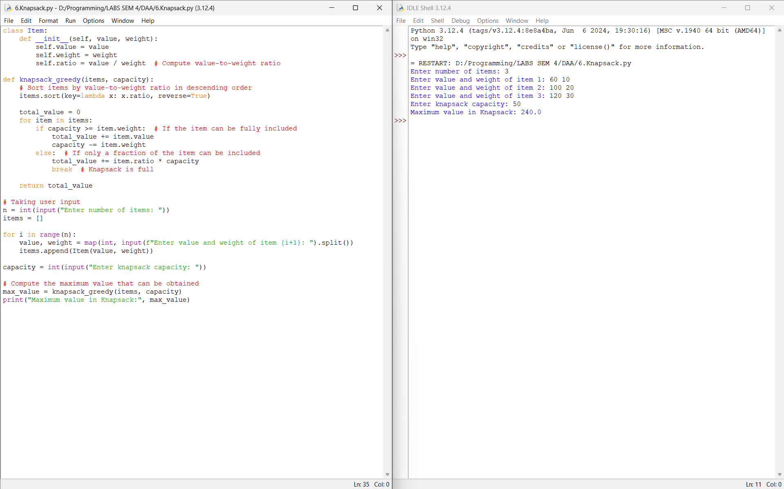

Conclusion:
Hence, I have executed the python program to find solution for knapsack problem by using Greedy method successfully.

